Weather Instruments Info

Subject: Surface area, air flow, air pressure, magnetism, water, expansion  Related Subjects: | Grade Level(s):k-4,5-8  Length of Lesson: | Type: Inquiry / Design / Project  Keywords: Magnetic field, flow, vector, circumference, evaporation

Lesson Overview
Students will create a weather vane and a compass to measure wind direction, an anemometer to determine speed, a hygrometer (psychrometer) to determine humidity, a thermometer to measure temperature and a barometer to measure atmospheric pressure

Lesson Focus
What is the central question or phenomenon being investigated? What problem are they trying to solve?

Lesson Objective(s) | - Students will create weather vane.  - Students will create anemometer  - Students will create water compass.  - Students will create thermometer  - Students will create a sling psychrometer  - Students will measure wind flow on various parts of campus.  - Students will record direction and speed of wind flow.  - Students will convert feet per minute to miles per hour.  - Students will mark wind flow directions and speed on enlarged campus map with vector arrows.  - Students will measure temperature  - Students will measure relative humidity  - Students will measure air pressure

Lesson Timing

5 minutes | Introduce the Lesson
30 minutes | ...

Materials | - –Cardboard tray  - –3 straws  - –2 pencils  - –5-3oz cups  - –3-5oz cups  - –1-7oz cups  - –3x5card  - –1 Needle  - –3 Pins  - –Scissors  - –Stapler  - –Styrofoam  - –Water  - –Tape  - –Hot glue gun  - –Magnet  - –Toothpick  - –Calculator  - –Campus map  - –Enlarged Thomas Guide map of school area  - –3 mercury thermometers  - –20 oz soda plastic soda  - –Nylon string  - –Toilet tissue  - –Tap water  - –Rubbing alcohol (do not drink this)  - –Clear, narrow-necked plastic bottle (11-ounce water bottles work well)  - –Food coloring  - –Clear plastic drinking straw  - –hole puncher  - –Match  - –Latex  - –Water bottle  - –Food coloring
Instructor Prep | - Step 1
Related Resources | - www.denninger.com  - http://es.rice.edu/ES/humsoc/Galileo/Things/thermometer.html

Lesson Plan

Introduction
Weather Vanes are used to tell the direction of wind flow. The anemometer is used to tell wind speed. The compass is used as a way to tell direction.

There are only two basic rules that must be followed when designing a weather vane: 1.) The ornament must have unequal area on either side of center. 2.) The ornament must have equal mass on either side of center.

The history of weather vanes is an interesting one which spans many centuries and travels over many countries.

The earliest recorded weather vane honored the Greek god Triton, and

adorned the Tower of the Winds in Athens which was built by the astronomer Andronicus in 48 B.C. The figure, which is believed to have been 4 to 8 feet long, had the head and torso of a man and the tail of a fish. To the ancients, the winds had divine powers. In Greece and pre-Christian Rome, weather vanes depicting the gods Boreas, Aeolus, Hermes and Mercury decorated the villas of wealthy landowners.

Archaeologists have discovered bronze Viking weather vanes from the 9th century. They have an unusual quadrant shape, usually surmounted by an animal or creature from Norse fable. They were commonly used on Viking ships, and were also popular on Scandinavian churches. These weather vanes can be seen even today in Sweden and Norway.

In the ninth century A.D., the pope reportedly decreed that every church in Europe should show a cock on its dome or steeple, as a reminder of Jesus' prophecy that the cock would not crow the morning after the Last Supper, until the disciple Peter had denounced Him three times (Luke 22:34). Because of this story, "weather cocks" have topped church steeples for centuries, both in Europe and in America. The 11th century Bayeux Tapestry even includes a scene of a craftsman attaching a rooster vane to the spire of the Westminster Abbey.

It is probably the banners which flew from medieval towers in Britain, Normandy and Germany which are the precursors to our modern weather vanes. The word "vane" actually comes from the Anglo-Saxon word "fane", meaning "flag". Originally, fabric pennants would show the archers the direction of the wind. Later, the cloth flags were replaced by metal ones, decorated with the insignia or coat of arms of the lord or nobleman, and balanced to turn in the wind. From these antecedents come the banners which the early American colonists favored for their meeting halls and public buildings.

America's first documented weather vane maker, Deacon Shem Drowne, created the famous grasshopper vane atop Boston's Faneuil Hall (1742), as well as the banner for Boston's Old North Church (1740), the rooster now on First Church in Cambridge (orig. 1721), and the large copper Indian for Boston's Province House (1716). Thomas Jefferson attached the weather vane on Monticello to a pointer in the ceiling of the room directly below, so he could read the direction of the wind from inside his home. And George Washington commemorated the end of the Revolutionary War by commissioning a "Dove of Peace" weather vane from Joseph Rakestraw in 1787, for his estate at Mount Vernon.

In the early 1800's, Americans favored weather vanes in patriotic designs, including the Goddess of Liberty, and of course, the Federal Eagle. By the middle of the century, vanes of famous racing horses like "Black Hawk", "Smuggler" and "George M. Patchen" were being modeled after the popular Currier and Ives prints. In the 19th century, there were many weather vane manufacturers mass-producing vanes in dozens of designs. Some of the more famous makers were L. W. Cushing, J. W. Fiske, Harris & Co., A. L. Jewell & Co., and E. G. Washburne & Co.

In the last decades of the 19th century, Victorian buildings had fancy weather vanes and elaborate metalwork embellishing almost every inch of roof space. We have found that Victorian style copperwork, de rigueur on Queen Anne, Second Empire, Richardsonian and Tudor buildings, is in great demand for the Victorian Revival homes of today. After 1900, the movement to a simpler style of architecture was reflected in the silhouette weather vane, which often depicted sporting scenes or figures of a humorous nature.

Use of the magnetic compass for navigation is said to have begun about the 12th century AD.

A hygrometer is an instrument used to measure the moisture content or the humidity of air or any gas. The best known type of hygrometer is the "dry and wet-bulb psychrometer", best described as two mercury thermometers, one with a wet base, one with a dry base. The water from the wet base evaporates and cools causing the thermometer reading to drop. Using a table, the reading from the dry thermometer and the reading drop from the wet thermometer are used to determine the relative humidity.

Some common hygrometers use human hair to determine moisture content. These work because human hair contracts and expands in response to the relative humidity. The contraction and expansion moves a needle guage. In 1783, Swiss physicist and geologist, Horace Bénédict de Saussure built the first hygrometer using a human hair to measure humidity. Leonardo da Vinci built the first crude hygrometer in the 1400s. Francesco Folli invented a more practical hygrometer in 1664.

At the start of the seventeenth century there was no way to quantify heat. In Aristotelian matter theory, heat and cold were fundamental qualities. Like dry and wet, heat and cold were qualities combined with "prima materia" to make up the elements, earth, water, air, and fire. Thus earth was dry and cold, fire dry and hot, etc. Although one might speak of "degrees of heat or cold," there was no formal distinction between what we would call the extensive concept of heat and the intensive concept of temperature. Also these degrees were not measured, except perhaps in a very rough way as when a physician put his hand on a patient's forehead and diagnosed "fever heat."

Measuring heat became a puzzle in the circle of practical and learned men in Venice to which Galileo belonged. The first solution was a thermoscope. Building on Pneumatics by Hero of Alexandria (1st century BCE), first published in the West in 1575, several authors had begun playing with the idea of the expansion of air as its heat increased, and vice versa. The first versions, usually called thermoscopes, were little more than toys. Over the next several years this thermoscope was developed by Santorio Santorio and Galileo's friend Gianfrancesco Sagredo (both in Venice), Galileo, and others to include a numerical scale. It had thus become a full-fledged air thermometer. The first series of quantitative meteorological observations date from this period. In other parts of Europe the inventor Cornelis Drebbel and Robert Fludd developed similar instruments. The questions about who was the first, and whether one derived his knowledge from another, are sterile ones which shed little light on the historical context in which this and other instruments (e.g., the telescope and barometer) developed. The near simultaneous (and surely independent) invention of the air thermometer illustrates the seventeenth-century trend toward quantification of natural phenomena--an essential dimension of the "mathematization of nature."

The liquid in glass thermometer was developed in the 1630s, but a universal standard of temperature remained elusive. Each scientist had his own scale divisions, often based on different reference points. It is impossible for us accurately to convert their measurements to our temperature scale, and at the time it was impossible to compare temperatures in different places. In the early eighteenth century, universal temperature scales based on several fiduciary points (e.g. a mixture of ice and brine, a mixture of ice and water, body temperature, the boiling point of water) were developed by Daniel Gabriel Fahrenheit (1686-1736), Anders Celsius (1701-1744), and René-Antoine Ferchault de Réaumur (1683-1757). Of these, the first two are still in use, and the system of Celsius (extended to become an absolute scale in the nineteenth century) has become the standard scientific temperature scale.

Air pressure around us affects our weather. Meteorologists and weathermen describe pressure systems such as low pressure systems and high pressure systems and how they will affect tomorrow's weather. Torricelli's invention, the barometer, also known as the "Torricelli's tube", measures atmospheric pressure. Evangelista Torricelli, born October 15, 1608 in Faenza, Italy and was a physicist and mathematician. In 1641, he moved to Florence, Italy to assist the Galileo. Galileo suggested Torricelli use Mercury in his vacuum experiments. Torricelli filled a 4 ft long glass tube with mercury and inverted the tube into a dish. Some of the mercury did not escape from the tube and Torricelli observed the vacuum that was created. He became the first scientist to create a sustained vacuum and to discover the principle of a barometer. Torricelli discovered that the differences in the height of the mercury from day to day was caused by changes in the atmospheric pressure.

Procedure
- –Hot glue a 5oz cup upside down to cardboard tray.
- –Cut 4 small triangles (1/2” in height) from 3x5 card and label N,S,E,W
- –Tape triangles to bottom of a 5oz cup with in the order N, E, S and W at 90° angles. This is your direction setter.
- –From remainder of 3x5 card cut a 1”x 1.5” triangle and a 3” x 2.5” triangle.
- –Sharpen a pencil to 5” in height, and use it to poke holes into the center of the bottoms of the 7oz cup and direction setter.
- – Insert pencil into 7oz cup (with eraser pointing up) and hot glue in place.
- –Place direction setter over 7 oz cup and pencil so that it rotates.
- –Insert a stickpin through the midpoint of a straw.
- –With the pin perpendicular to the ground, make a ½“ incision on one end and a ¾“ incision on the other. The incisions should be on the same axis as the pin.
- –Insert the base of the small triangle into the ½“ incision and tape into place.
- –Insert top of large triangle in to ¾” incision and tape into place.
- –The triangles and pins should be on same axis (see figure 1).
- –Insert pin into top of pencil. Your weather vane is complete.

The Compass

- –Cut a 5oz cup to 1” in height and glue to cardboard tray.
- –Break ½” from top of toothpick and glue to the center of cup ½” cut cup in middle of cardboard tray.
- –Cut a 1” diameter of Styrofoam and make small indentation on one side (this will be the bottom).
- –Rub the head of a needle against a magnet 50 times.
- –Tape the needle to the top of the Styrofoam so that its weight is equally distributed.
- –Pour water into cup until water reaches tip of toothpick.
- –Place Styrofoam on water so that it rests on toothpick.
- –Add water until the needle can turn freely, but doesn’t float off of toothpick.
- –Determine which direction is north and not which end of needle faces that direction.
– The compass is now complete.

The Anemometer

- –Hot glue 7oz cup upside down to cardboard tray.
- –Punch one hole in four of the 3oz cups about ½“ below the rim.
- –Take the 5th 3oz up and punch 4 equally spaced holes about ¼” below the rim and a hole in the center of the bottom of the cup.
- –Insert straw through hole of one of the cups, fold the end of the straw about ¼” and staple to the other side of cup across from the hole.
- –Insert 2nd straw through hole of another of the cups, fold the end of the straw about ¼” and staple to the other side of cup across from the hole.
- –Slide straw from straw/cup through opposite holes on four hole cup.
- –Insert straw/cup straw through hole of one of the free cups, fold the end of the straw about ¼” and staple to the other side of cup across from the hole making certain that the two cups face different directions when one faces you (see figure 2).
- – Slide straw from straw/cup through other opposite holes on four hole cup.
- – Insert remaining straw/cup straw through hole of remaining free cups, fold the end of the straw about ¼” and staple to the other side of cup across from the hole making certain that the two cups face different directions when one faces you.
- –Align the four cups so that their open ends face the same direction clockwise or counterclockwise (see figure 3).
- –Push the pin through the two straws where they intersect.
- –Make a hole in the 5oz cup on cardboard tray and insert 7” sharpened pencil and hot glue in place.
- –Attach cup structure to pencil by pushing it so pencil passes through hole in center cup.
- –Push pin in straws through eraser of pencils.
- –Mark one of the spinning cups.
- –Calculate the circumference of the circle created by cups of the anemometer in feet.
- –Your anemometer is complete.

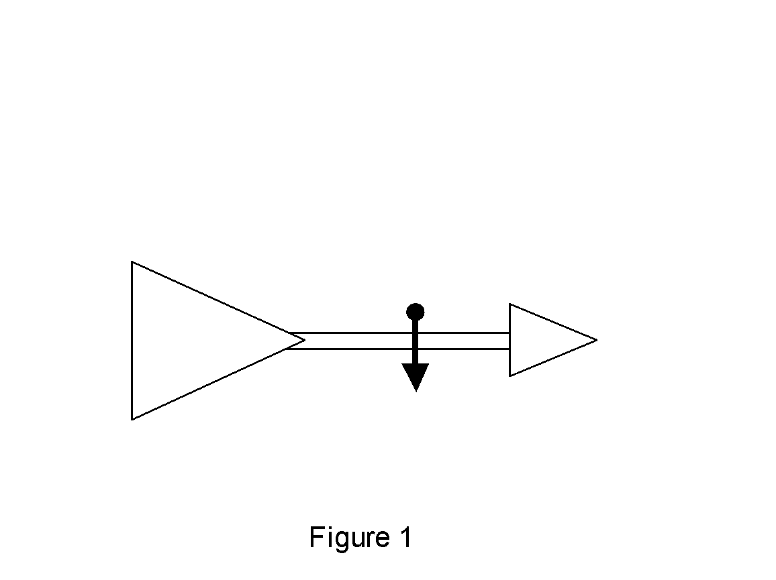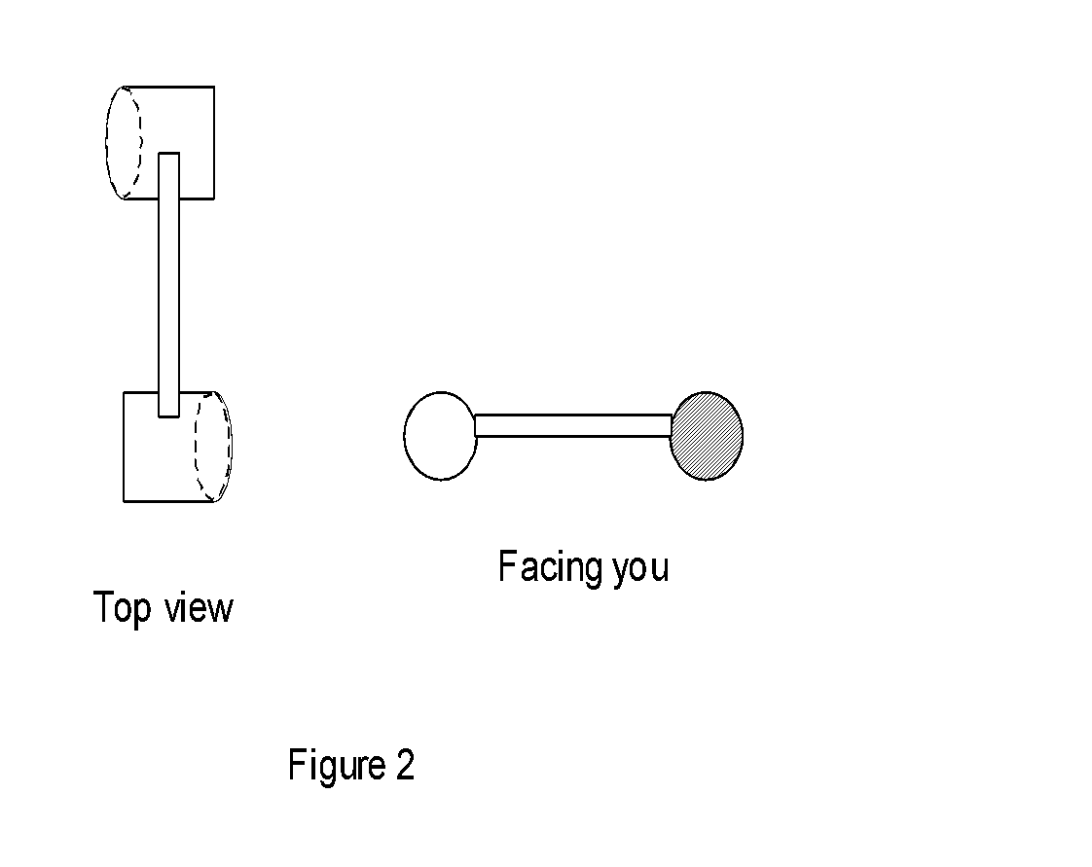

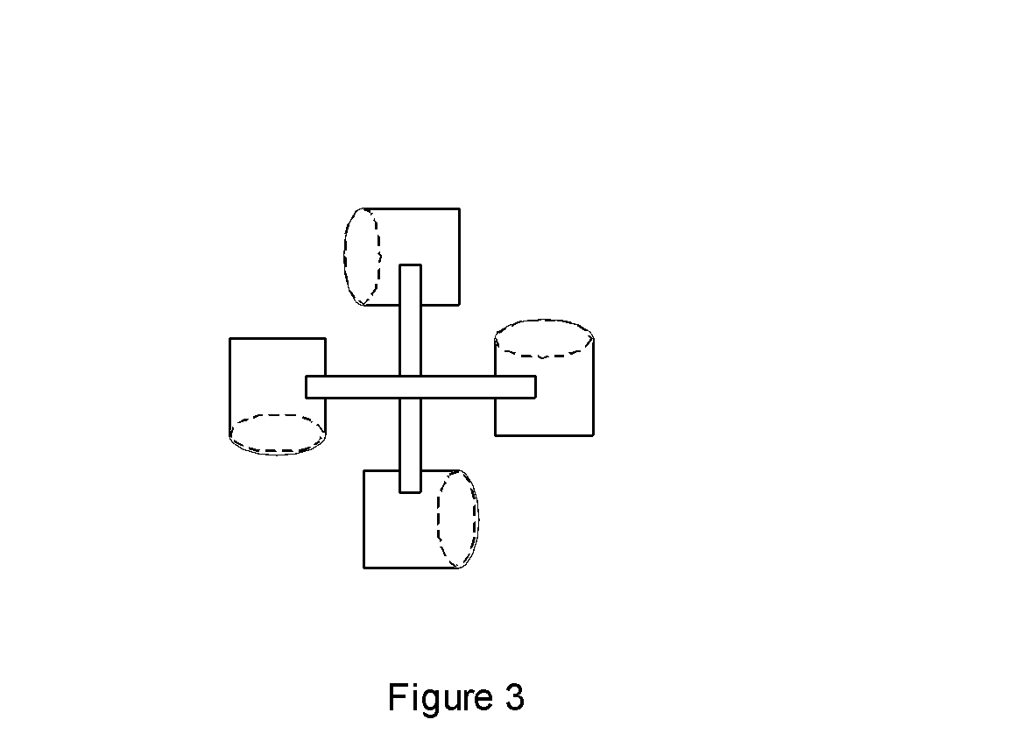

USING THE W.A.C.

- – To take measurements, rotate direction setter so that N faces the north direction.
- –Note the direction of the wind.
- –Place W.A.C. in a stationary location where there is a wind.
- –Note the number of times the marked cups spins in 1 minute.
- –Calculate the wind speed by multiplying the revolutions per minute times the circumference of the anemometer.
- –Convert the speed to miles per hour by multiplying speed by 60 (there are 60 minutes in an hour) and by dividing by 5280 (there are 5280 feet in one mile.
- –Using the scale of ½” = 1mile, draw a vector arrow on campus map indicating direction and speed of wind in measurement location.

The Thermometer

- –Pour equal parts of tap water and rubbing alcohol into the bottle, filling about 1/8 to a 1/4 of the bottle.
- –Add a couple of drops of food coloring and mix.
- –Put the straw in the bottle, (DO NOT DRINK MIXTURE) but don't let the straw touch the bottom.
- –Carefully hot glue straw to seal the neck of the bottle, so the straw stays in place.
- –This is basically your thermometer. But you will need to mark temperatures onto a scale and you will need a real thermometer to do this.
- –Fill a bucket or saucepan with cold water and add ice. Put the homemade thermometer and a real thermometer into the bucket and record the temperature on the real thermometer. Mark off the level of liquid on the made thermometer. Add warm water gradually, marking off the temperatures at 5, 10, 20, 25 and 300C.

The Hygrometer

Method 1 Pyschrometer

- –Securely tape the two thermometers to the soda bottle pipe with the numbers facing up and the liquid filled ends sticking over the end of the pipe about 2.5 cm (1 inch).
- –Using the rubber band, tie the wet toilet tissue around the liquid filled end of one thermometer.
- –Tie a string securely to the top of the soda bottle
- –Spin the bottle in a circle of above your head for 3 minutes
- –Write down the temperature on both thermometers.
- –Sub the temperature on the wet thermometer from that of the dry one.
- –Look at the table below. Find the dry thermometer temperature on the left and Follow it to the right. Find the difference between the two temperatures on the top, and follow it down. The number where the row and column intersect is the relative humidity.

Dry Bulb Dry Bulb Minus Wet Bulb (degrees celsius)
°C | 1 | 2 | 3 | 4 | 5 | 6 | 7 | 8 | 9 | 10
10 | 88 | 77 | 66 | 55 | 44 | 34 | 24 | 15 | 6
11 | 89 | 78 | 67 | 56 | 46 | 36 | 27 | 18 | 9
12 | 89 | 78 | 68 | 58 | 48 | 39 | 29 | 21 | 12
13 | 89 | 79 | 69 | 59 | 50 | 41 | 32 | 22 | 15 | 7
14 | 90 | 79 | 70 | 60 | 51 | 42 | 34 | 25 | 18 | 10
15 | 90 | 81 | 71 | 61 | 53 | 44 | 36 | 27 | 20 | 13
16 | 90 | 81 | 71 | 63 | 54 | 46 | 38 | 30 | 23 | 15
17 | 90 | 81 | 72 | 64 | 55 | 47 | 40 | 32 | 25 | 18
18 | 91 | 82 | 73 | 65 | 57 | 49 | 41 | 34 | 27 | 20
19 | 91 | 82 | 74 | 65 | 58 | 50 | 43 | 36 | 29 | 22
20 | 91 | 83 | 74 | 67 | 59 | 53 | 46 | 39 | 32 | 26
21 | 91 | 83 | 75 | 67 | 60 | 53 | 46 | 39 | 32 | 26
22 | 91 | 83 | 76 | 68 | 61 | 54 | 47 | 40 | 34 | 28
23 | 92 | 84 | 76 | 69 | 62 | 55 | 48 | 42 | 36 | 30
24 | 92 | 84 | 77 | 69 | 62 | 56 | 49 | 43 | 37 | 31
25 | 92 | 84 | 77 | 70 | 63 | 57 | 50 | 44 | 39 | 33
Method 2 Human hair:
- Cut a small triangle (1/2” height) from index card.
- Cut slit in a straw
- Insert triangle into straw
- Cut a 1” x 6” strip and a 6” x 8” rectangle of foam board
- Glue the pieces together to create a stand

- Push a pin through a straw and into a sheet of foam board
- Push a second pin 4” below first pin ½” to the right
- Tie a human hair ¼” to straw behind pin
- Tie remaining end of human to second pin so that hair is tense but not tight.
- When the humidity changes, the hair will shrink or grow and the straw will move up or down.

The barometer

Method 1:
- Fill the jar with water and add some food coloring to it.
- Flip the empty water bottle upside down into the glass measuring cup.
- The bottle should fit snugly in the jar, but should not be airtight. The mouth of the bottle should not touch the bottom of the jar.
- The water should extend into the neck of the bottle.
- Mark a line on the cup to indicate the water level within the bottle.
- Make notes on the changes of the water level every few days.

Method 2:
Take a jar and seal the opening with latex stretched over the top, but not too tight.
Glue a matchstick into the end of a straw.
Glue the other end of the straw to the center of the latex. The matchstick is the pointer and the weight on the end of the straw.
Make a cardboard chart showing Pressure.
On a piece of foam board create lines every 1cm apart 15cm above and 15cm below the top of the jar.
Mark on the foam bard where the "pointer" is pointing when you create it. This is your air pressure for today.

Every few days create a mark where the “pointer” points and write the date next to it.

High Pressure Low pressure

Wrap-up
Students will take measurements at home at 6:30am and teacher will plot on enlarged Thomas Guide map.

Lesson Background for Teachers

Suggested Real-World STEM Connections
- List possible related Role Models in STEM (with details and links to more reading). Give suggestions for examples of scientists/engineers who are from underrepresented groups in STEM in related careers.
- List related real-world engineering problems and examples

Lesson Variations and Options
Include descriptions of alternative methods or ways to present things.

Explanation
The weather vane is one of the oldest weather tools. The part of the vane that turns into the wind is shaped like an arrow. The other end is wide so it will catch the smallest breeze. The breeze turns the arrow until it catches both sides of the wide end equally. The arrow always points into the wind and tells you the direction from which the wind is blowing.

The anemometer rotates at the same speed as the wind because its cups capture the wind and move at the same speed in a circle. Therefore it gives a direct measure of the speed of the wind. You calculate the number of revolutions per minute, circumference and you will then have the wind speed.

Magnets align themselves with the magnetic field of the Earth. The north pole of a magnet faces the North Magnetic Pole. Although the South Magnetic Pole isn’t directly aligned with the North Magnetic Pole, the south pole of magnets face it in general. By magnetizing a needle and allowing it to freely float, it will orient itself with the magnetic field of the Earth.

The bulb thermometer is the common glass thermometer you probably grew up with. The thermometer contains some type of fluid, generally mercury.
Bulb thermometers rely on the simple principle that a liquid changes its volume relative to its temperature. Liquids take up less space when they are cold and more space when they are warm. All bulb thermometers use a fairly large bulb and a narrow tube to accentuate the change in volume. Just like any thermometer, the mixture expands when it is warmed. This makes the liquid no longer fit in the bottom of the bottle. As the alcohol expands the colored mixture moves up through the straw. If the bottle were to get very hot, the liquid would have come through the top of the straw.

There are two ways to measure humidity

Method 1 psychrometer:
Relative humidity is measured using an instrument called a psychrometer. A psychrometer is composed of two thermometers—a wet-bulb thermometer and a regular thermometer. The wet-bulb thermometer in actuality is a regular thermometer. However, the bulb of the thermometer is covered with a piece of wet cloth. The other thermometer is called a dry-bulb thermometer. The two thermometers are attached to each other and swung around in the outside air.
When the air blows over the wet-bulb thermometer, the water in the cloth evaporates. Evaporation requires heat energy; therefore, the evaporation of water from the cloth cools the bulb of the thermometer. If the humidity is low, evaporation will occur rapidly and the temperature of the wet-bulb thermometer will fall at a fast pace. If the humidity is high, evaporation will occur at a slower rate causing the wet-bulb thermometer’s temperature to remain high.

In order to determine the relative humidity you must first find the difference between the dry-bulb temperature and the wet-bulb temperature. The differences between the two temperatures are calculated by using a table made by and available from the National Weather Service in Washington, D.C.
The barometer is a tool that lets you gauge the pressure of the air around you.

Method 2 Human Hair
Attach a human hair to a straw. As the moisture in the air changes, the straw will move as the hair length changes

There are two ways to measure air pressure

Method 1:
The air pressure changes the water level of in a tube. Increased air pressure moves water the level up. Decreased pressure moves the water level down. The amount of air within the bottle is fixed and cannot change since the water extended into the bottle acts as a 'plug'. The amount of air trapped in the bottle is an indicator of the air pressure on the day you plugged the bottle. The pressure on the surface of the water depends on the current air pressure. When the air pressure increases, the pressure on the surface of the water is greater and the water is forced up into the bottle changing the level of the water. In drier weather, the air pressure is usually greater.

Method 2:
The air pressure causes latex on a sealed jar to move up or down. As the air pressure increases, it pushes down on the top of the jar causing the latex to sink in which makes the pointer move up. If the pressure falls, the air inside the jar pushes up causing the latex to move up and the pointer to move down.

Key Concepts and Vocabulary
- Word 1: Grade Appropriate Definition
- Word 2: Grade Appropriate Definition

Safety Notes
- Students should exercise caution when using scissors.
- Students should exercise caution when using hot glue gun.
- Students should exercise caution when using pins and needles.
- Mercury is a toxic chemical. If a thermometer breaks, students should avoid contact with mercury.

